Given an m x n matrix mat, return *an array of all the elements of the array in a diagonal order*.

**Example 1:**

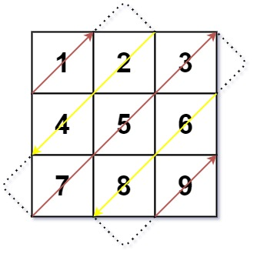

Input: mat = [[1,2,3],[4,5,6],[7,8,9]]  
Output: [1,2,4,7,5,3,6,8,9]

**Example 2:**

Input: mat = [[1,2],[3,4]]  
Output: [1,2,3,4]

**Constraints:**

* m == mat.length
* n == mat[i].length
* 1 <= m, n <= 104
* 1 <= m * n <= 104
* -105 <= mat[i][j] <= 105